**Result of Practical Quiz**

**Pemrograman Berbasis Objek**

**Class Modul Praktek**

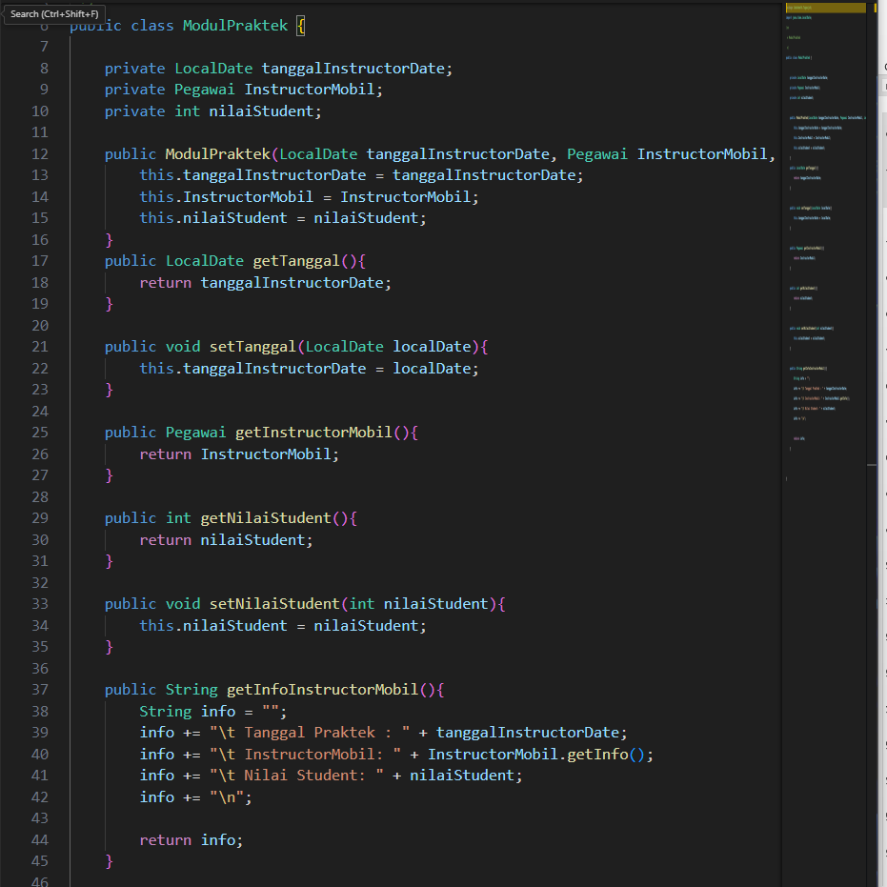

**Class Kursus Mengemudi**

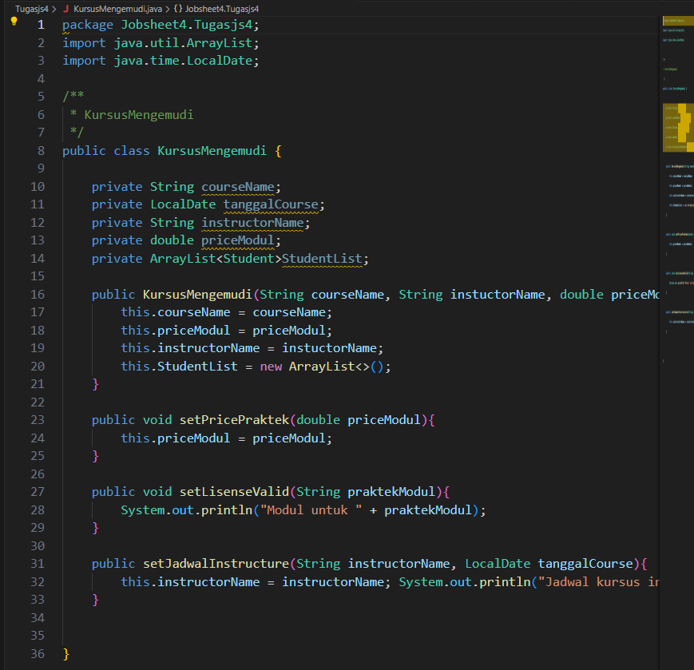

**Main Class Course Mobil**

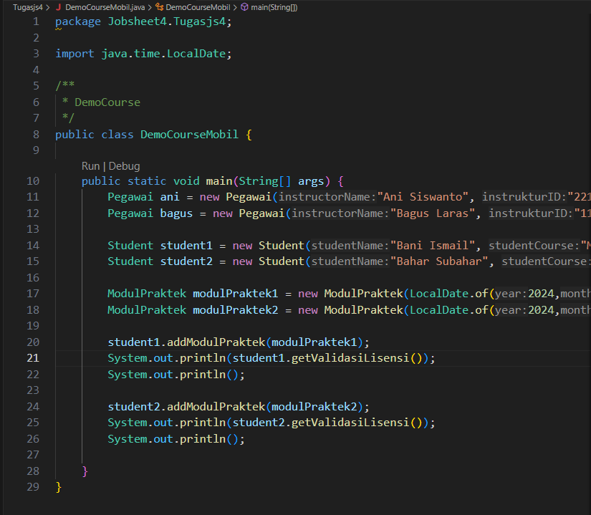

**Result Output of the Main Class**

